**Lab Assignments**

Data Communication and Networks



Submitted by: Submitted to:

Ajay Singh Dr. Vishakha Chourasia

(20U03058) (Asst. Professor)

Indian Institute of Information Technology, Bhopal

**Department of Information Technology**

Data Communication and Networks (IT-311)

Bachelor of Technology

3rd Year, 5th Semster

**Index: Table of Content**

|  |  |  |  |  |
| --- | --- | --- | --- | --- |
| S.No. | Assignment Name | Performance Date | Submission Date | Page No. |
| 1 | Know the Basics of Cisco Packet Tracer.  Download and work with CPT. | 27/07/2022 | 27/07/2022 | 3 |
| 2 | 1. Establish pair to pair communication and show that delivery of packets is successful check MAC and PHY address of systems.  2. Simulate LAN using HUB after setting show packet movement through simulation. | 03/08/2022 | 03/08/2022 | 14 |
| 3 | Study and Explore E-draw & Smart-draw Software. | 28/01/2022 | 04/02/2022 | 6 |
| 4 | Brief description about flowchart, its component and usability. | 04/03/2022 | 11/03/2022 | 10 |
| 5 | Types and Components of Data Flow Diagram (DFD) | 04/03/2022 | 11/03/2022 | 13 |
| 6 | Flow Chart and 0 level DFD for a real-world problem | 04/03/2022 | 11/03/2022 | 17 |
| 7 | Study about UML and Various diagrams use in the UML (class diagram, object diagram.. etc) | 06/04/2022 | 10/04/2022 | 20 |

ASSIGNMENT – 01

1. Know the Basics of Cisco Packet Tracer.
2. Download and work with CPT.

**Cisco packet Tracer: Intro**

* **Cisco**: The leaders in Networking.
* It is a cross-platform visual simulation tool designed by Cisco Systems that allows users to create network topologies and imitate modern computer networks.
* The software allows users to simulate the configuration of Cisco routers and switches using a simulated command line interface.
* Platforms: Windows, Linux, Android, MacOS.
* An innovative and powerful networking simulation tool used for practice, discovery and, troubleshooting.
* Helps to understand network practically.

**How to Download Cisco Packet Tracer…**

|  |  |  |  |  |
| --- | --- | --- | --- | --- |
| Step - 1    Step - 2    Step - 3 |  |  |  |  |



Step - 4



Step - 5



Step – 6

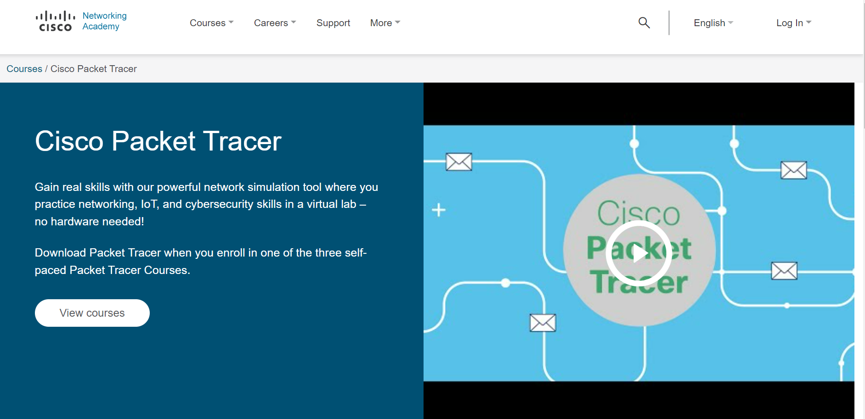

Step - 7

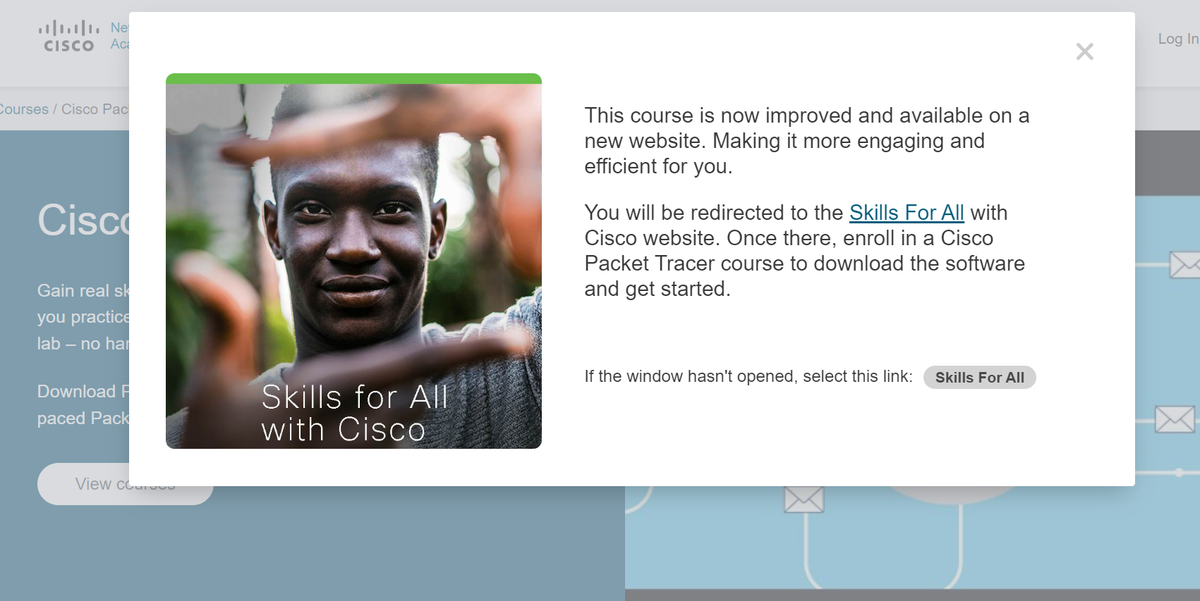

Step – 8

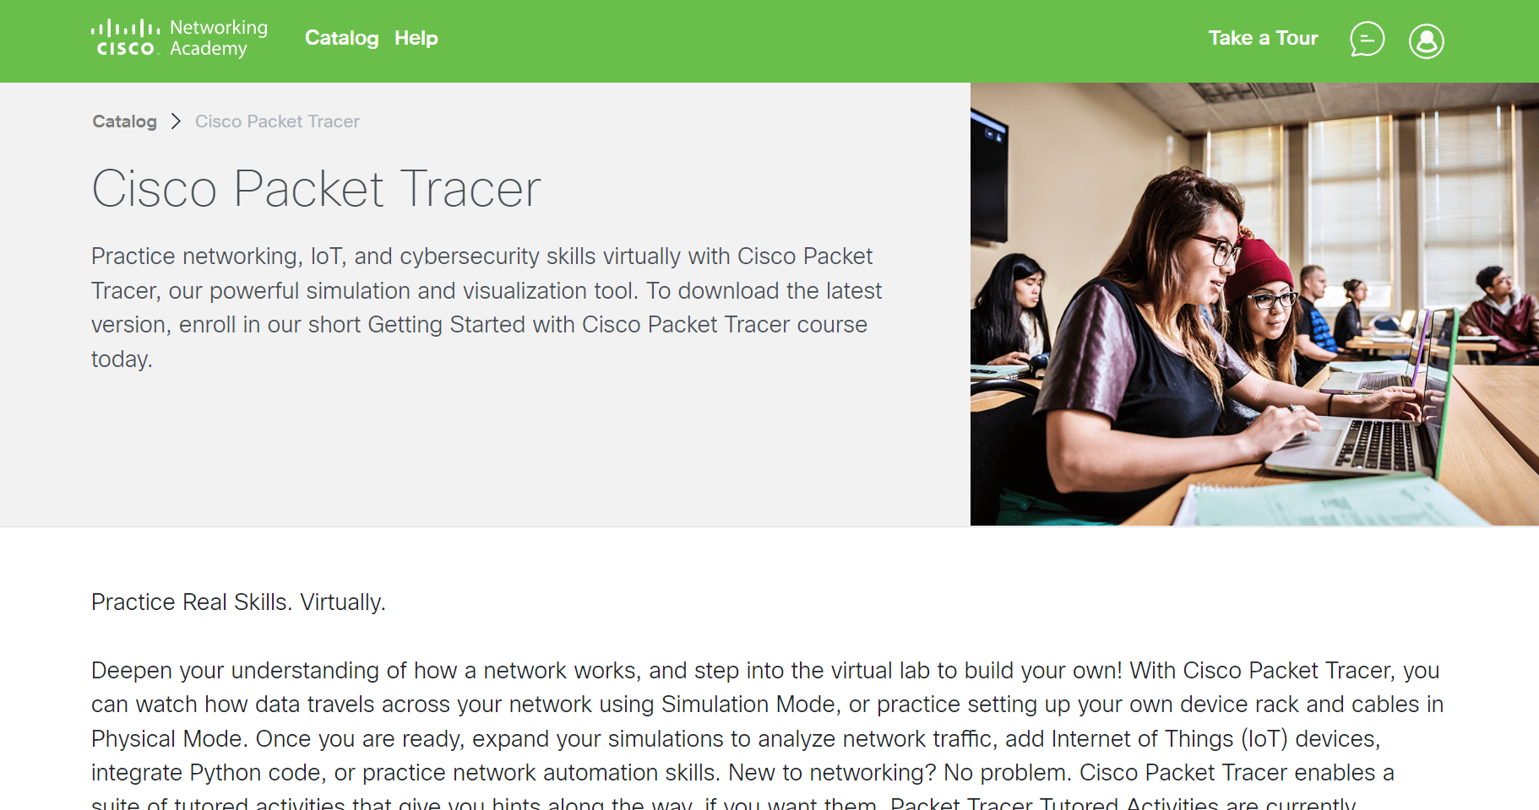

Step - 9



Step - 10

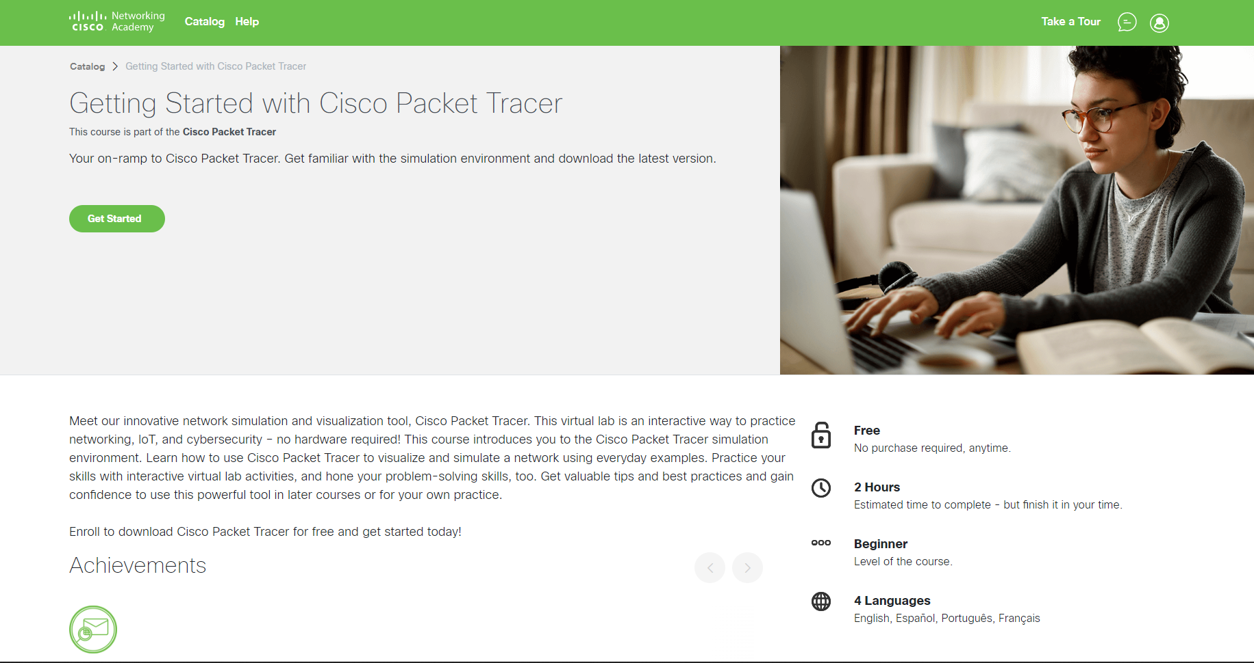

Step - 11

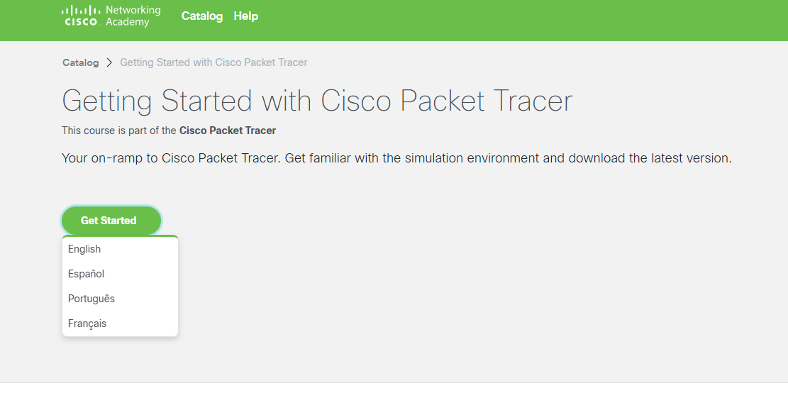

Step - 12



Step - 13

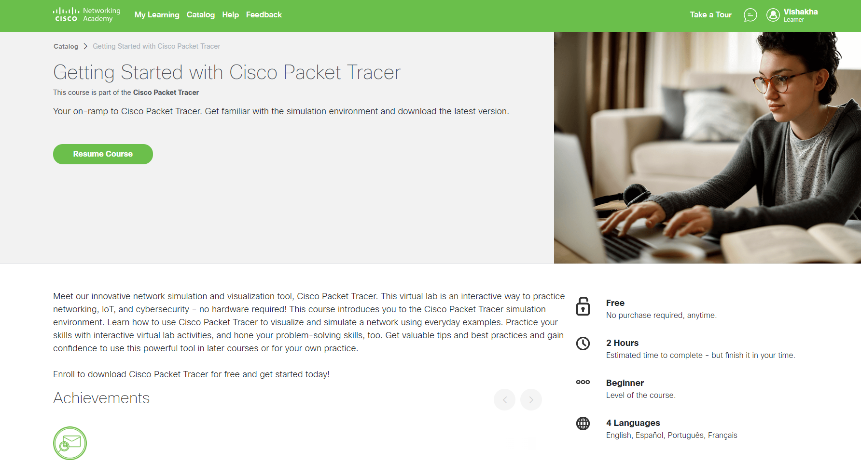

Step – 14

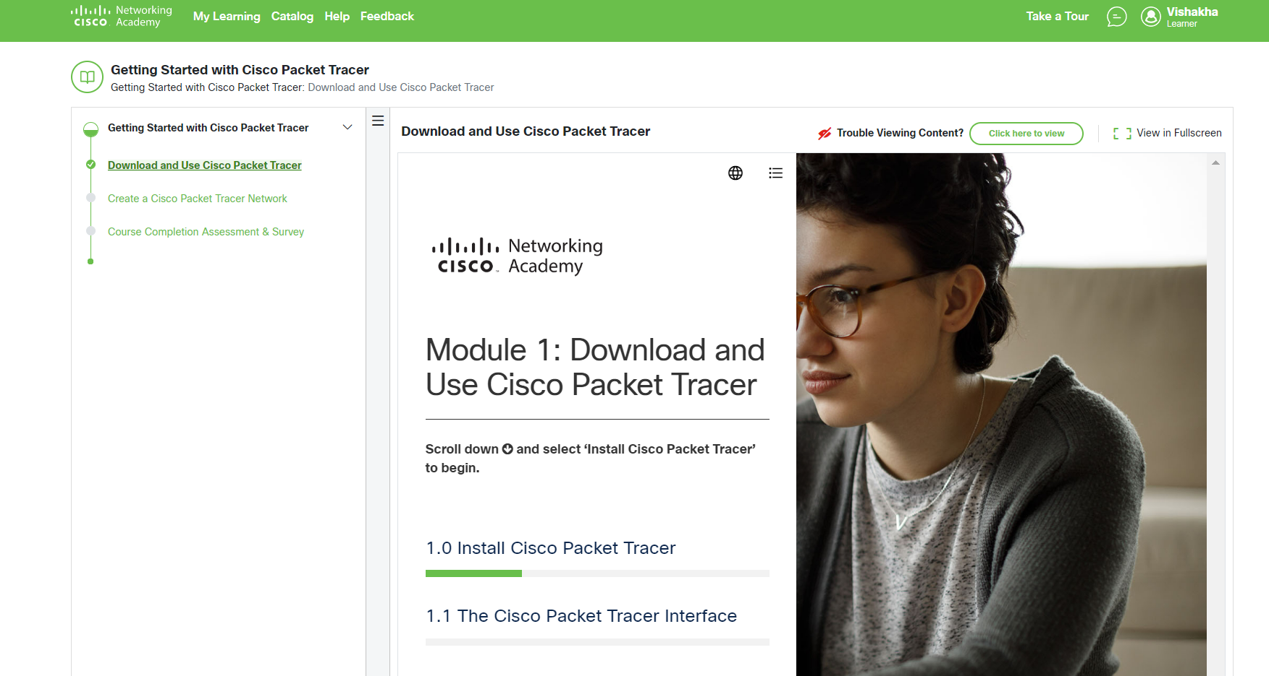

Step - 15

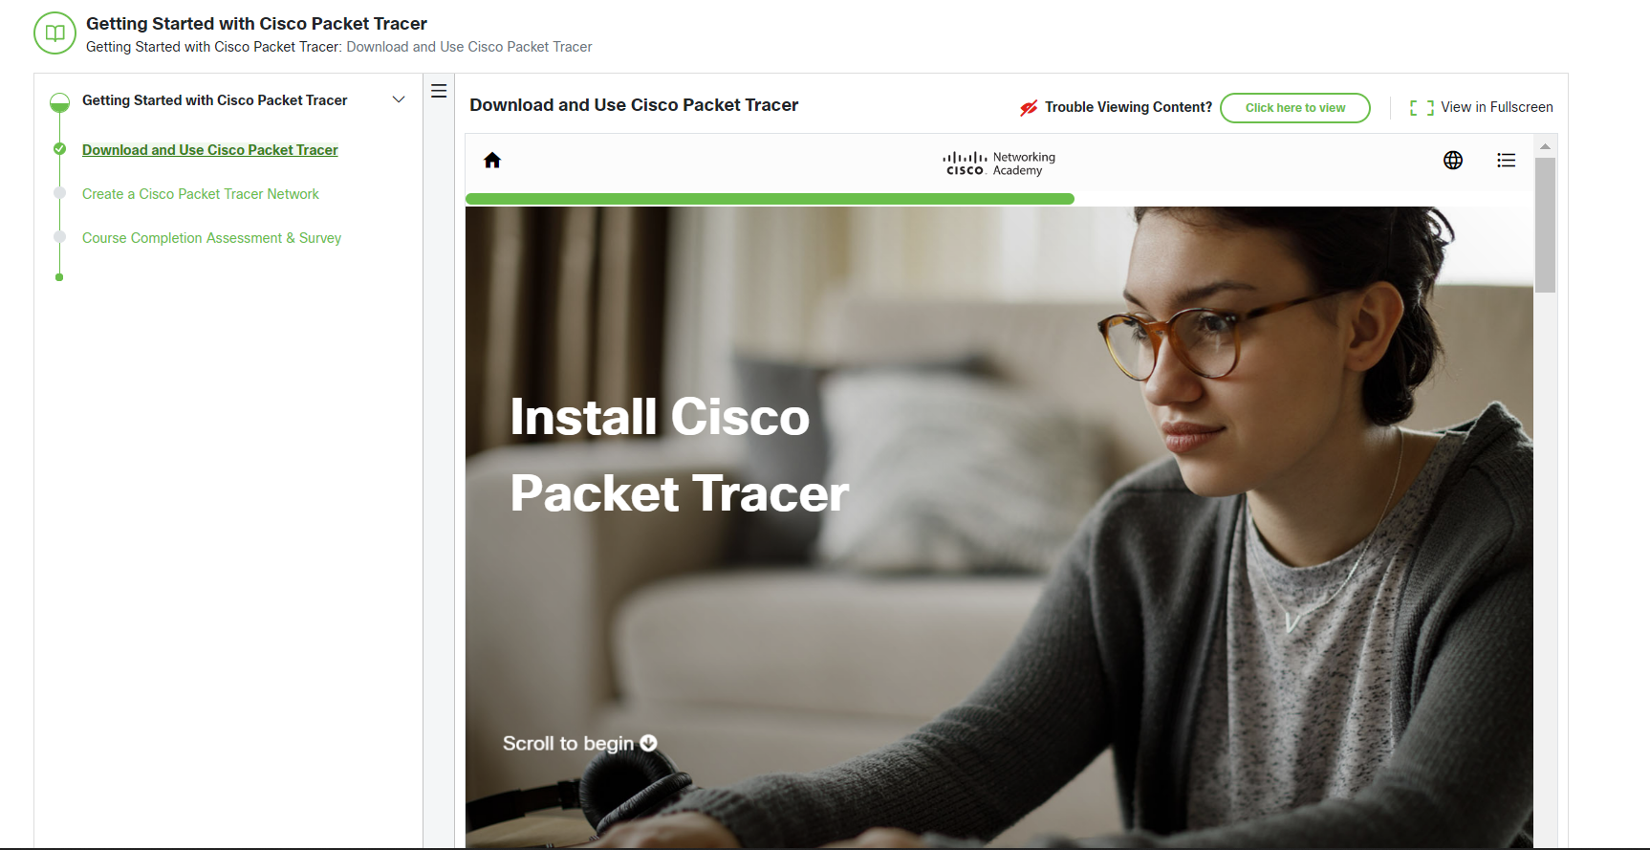

Step – 16

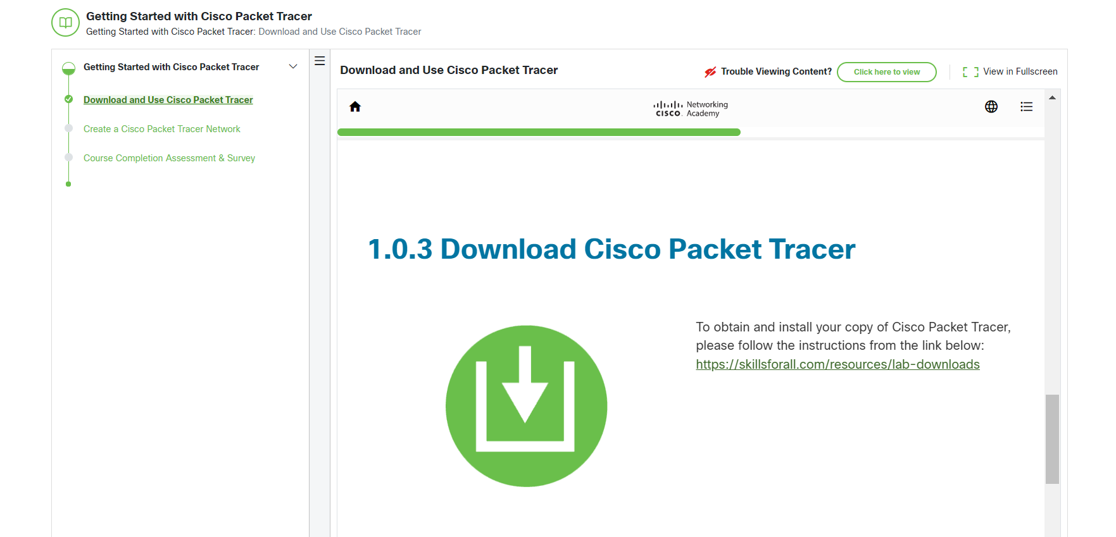

Step - 17

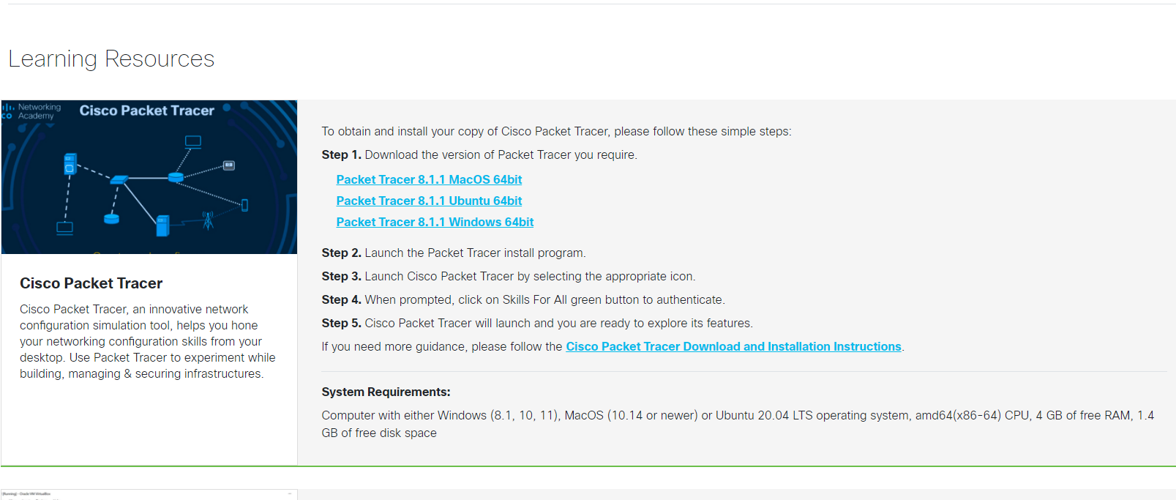

Step – 18

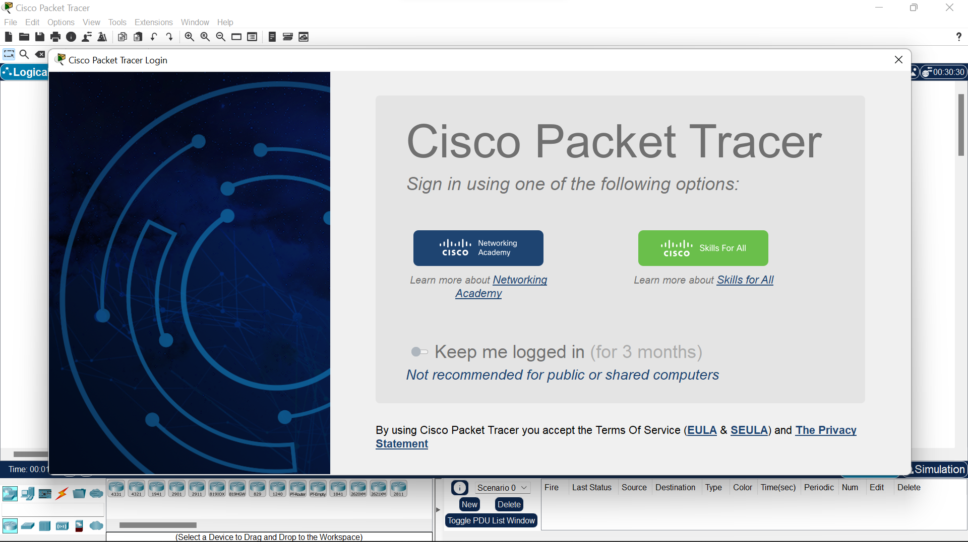

Step – 19

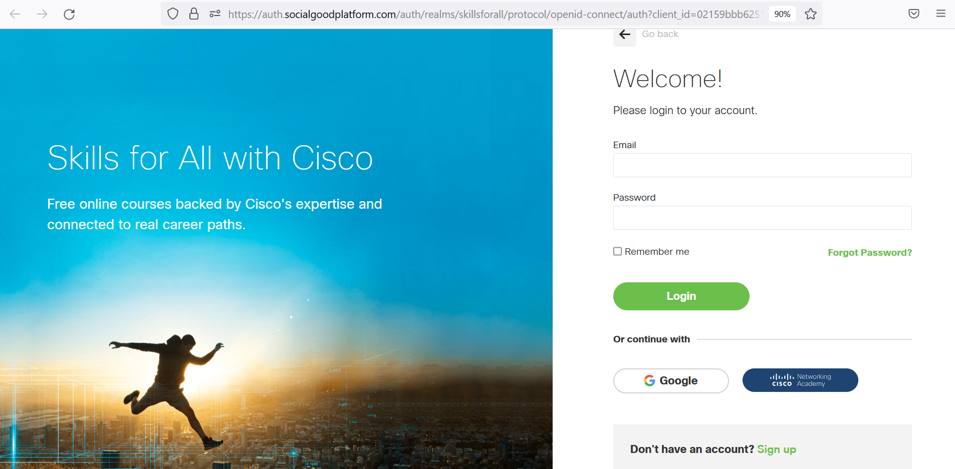

Step – 20

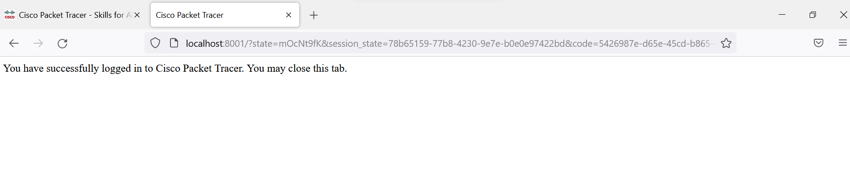

ASSIGNMENT – 02

Q. 1. Establish pair to pair communication and show that delivery of packets is successful check MAC and PHY address of systems.

Ans.

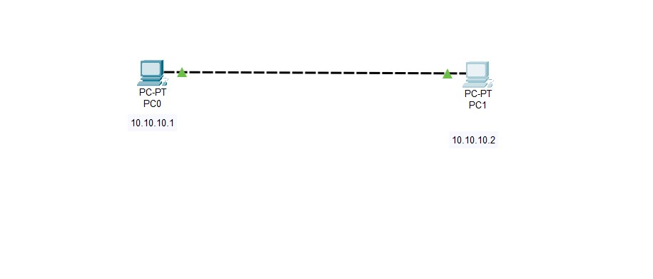

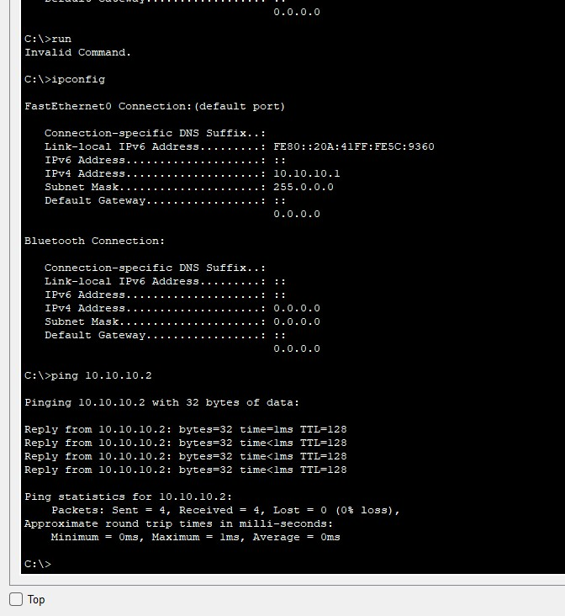

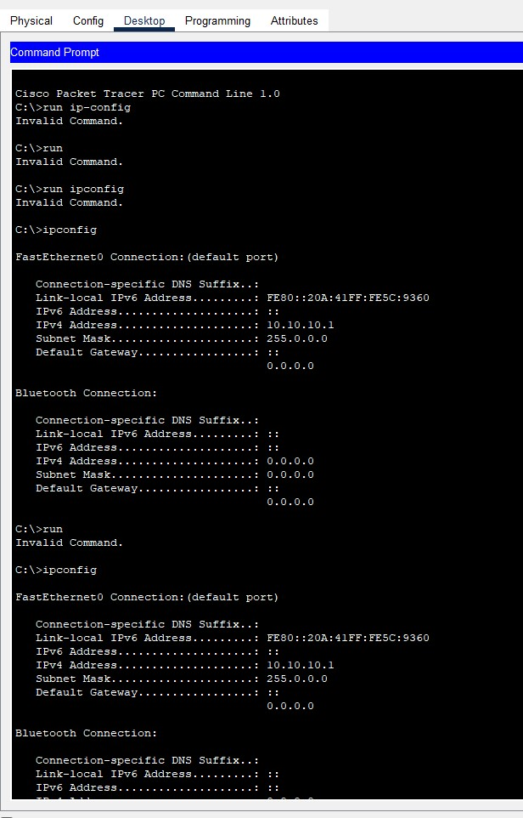

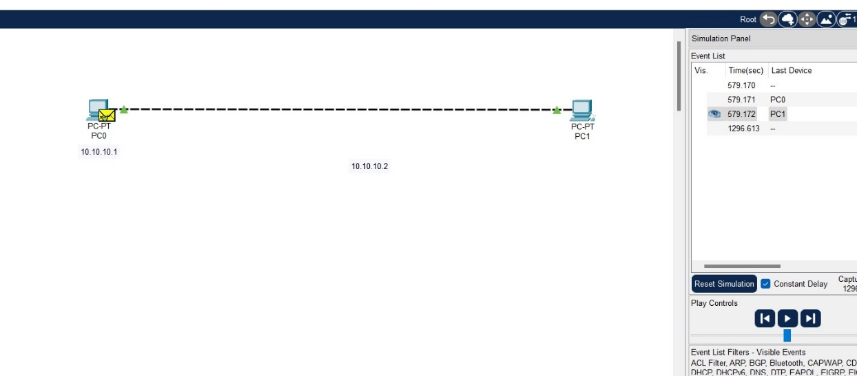

Q. 2. Simulate LAN using HUB after setting show packet movement through simulation.

Ans.

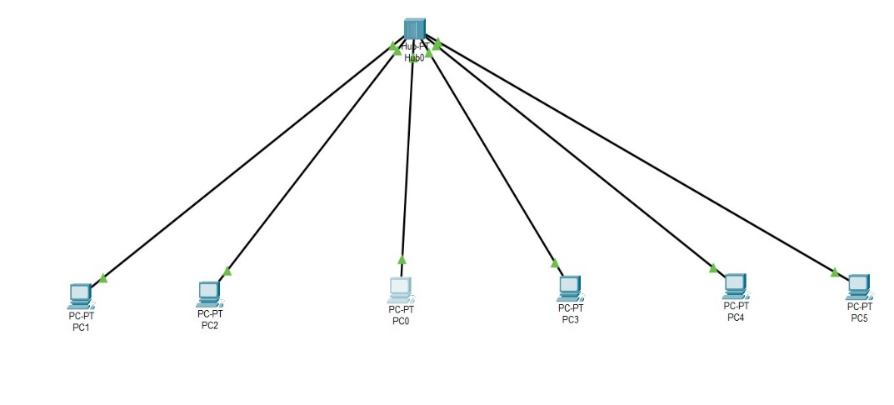

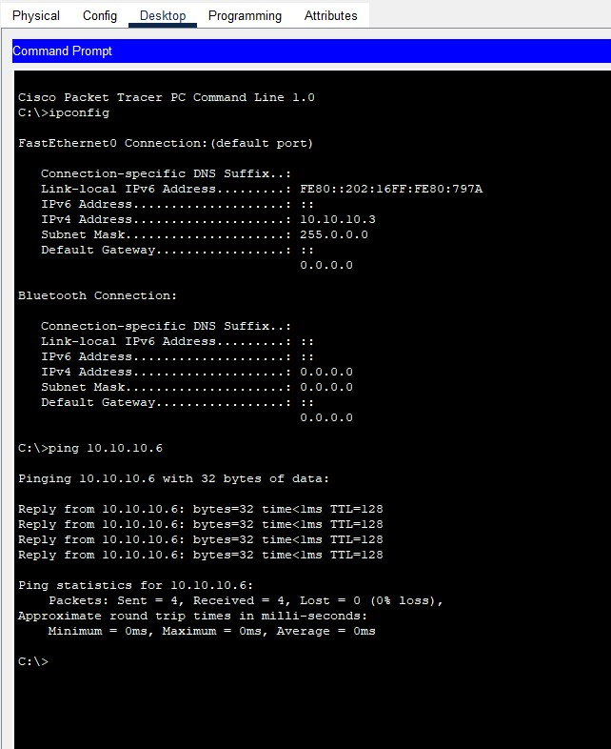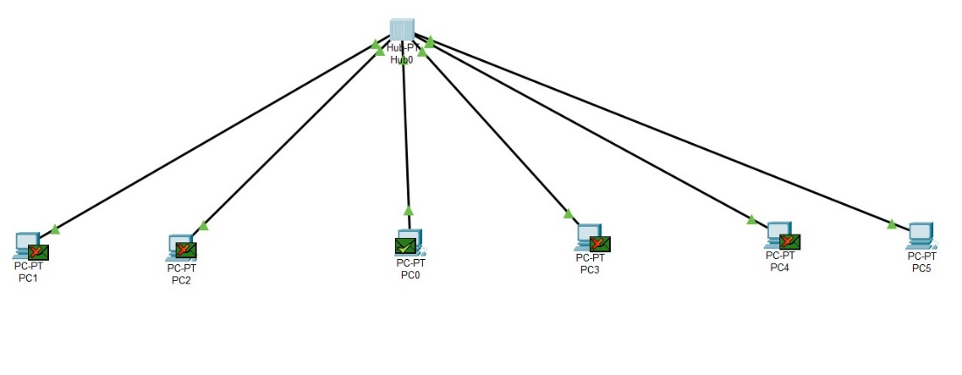

Q1

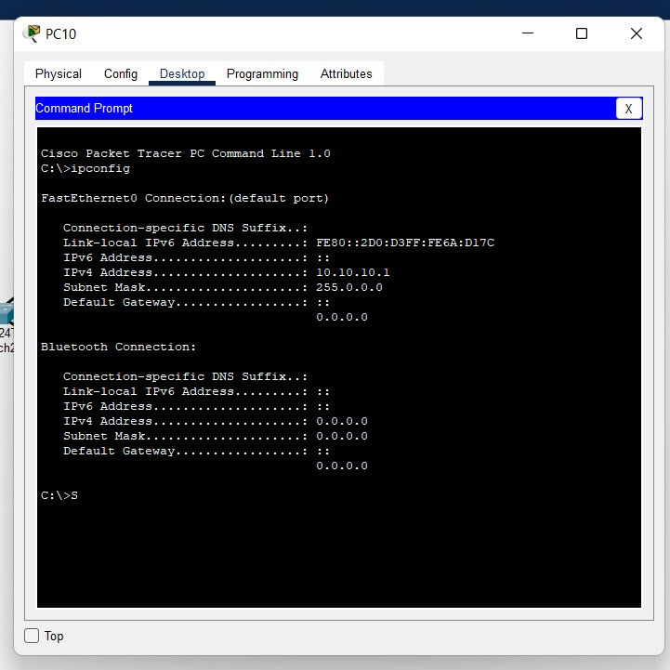

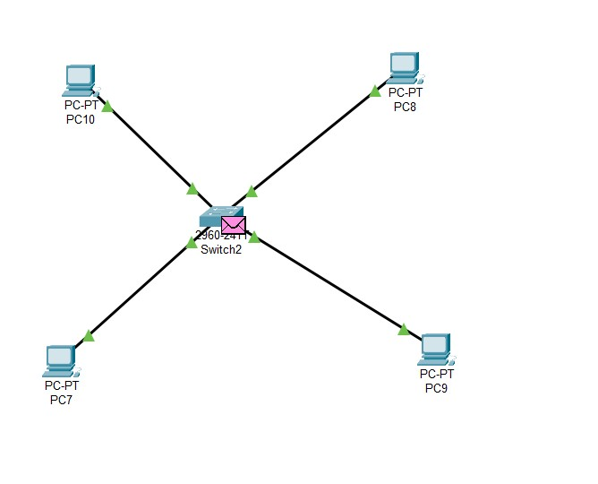

Q2

